# Module 3

**Transformers in Keras**

**Advanced Transformers and Sequential Data using TensorFlow**

## 📌 Advanced Transformer Applications

Transformers, originally developed for natural language processing, have evolved into a general-purpose architecture suitable for a wide variety of domains.

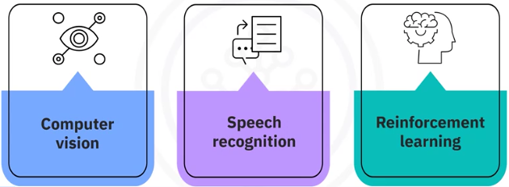Their ability to model sequences using self-attention mechanisms makes them highly effective in computer vision, speech recognition, and reinforcement learning.

### 📸 Transformers in Computer Vision

Transformers can be applied to images by treating them as sequences of patches.

**Vision Transformers (ViTs)** divide an image into smaller patches and treat each patch similarly to a word in a sentence. This enables the use of self-attention mechanisms on image data.

**Key Steps:**

1. Divide the input image into fixed-size patches.
2. Pass patches through a **patch embedding** layer to project them into vector representations.
3. Use a **transformer block** consisting of:
   * Multi-head self-attention mechanism
   * Feed-forward network
   * Residual connections and layer normalization
4. Stack multiple transformer blocks to form the **Vision Transformer model**.

**Components:**

**🔧TransformerBlock:**

Applies self-attention and feed-forward layers with residual and normalization steps.

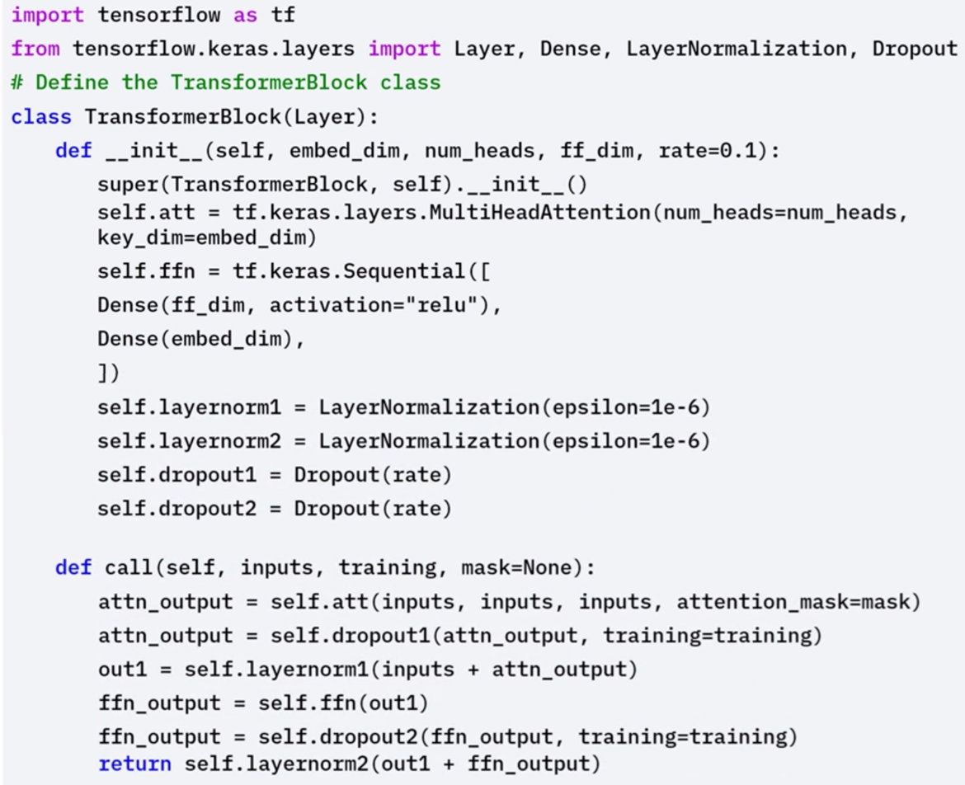

**🔧PatchEmbedding:**

Defines how image patches are converted into embedded vectors.

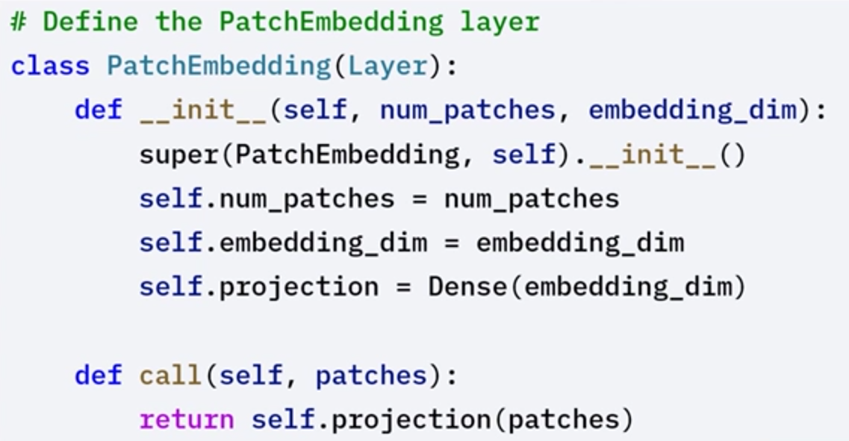

**🔧VisionTransformer:**

Combines patch embedding and stacked transformer blocks for image classification.

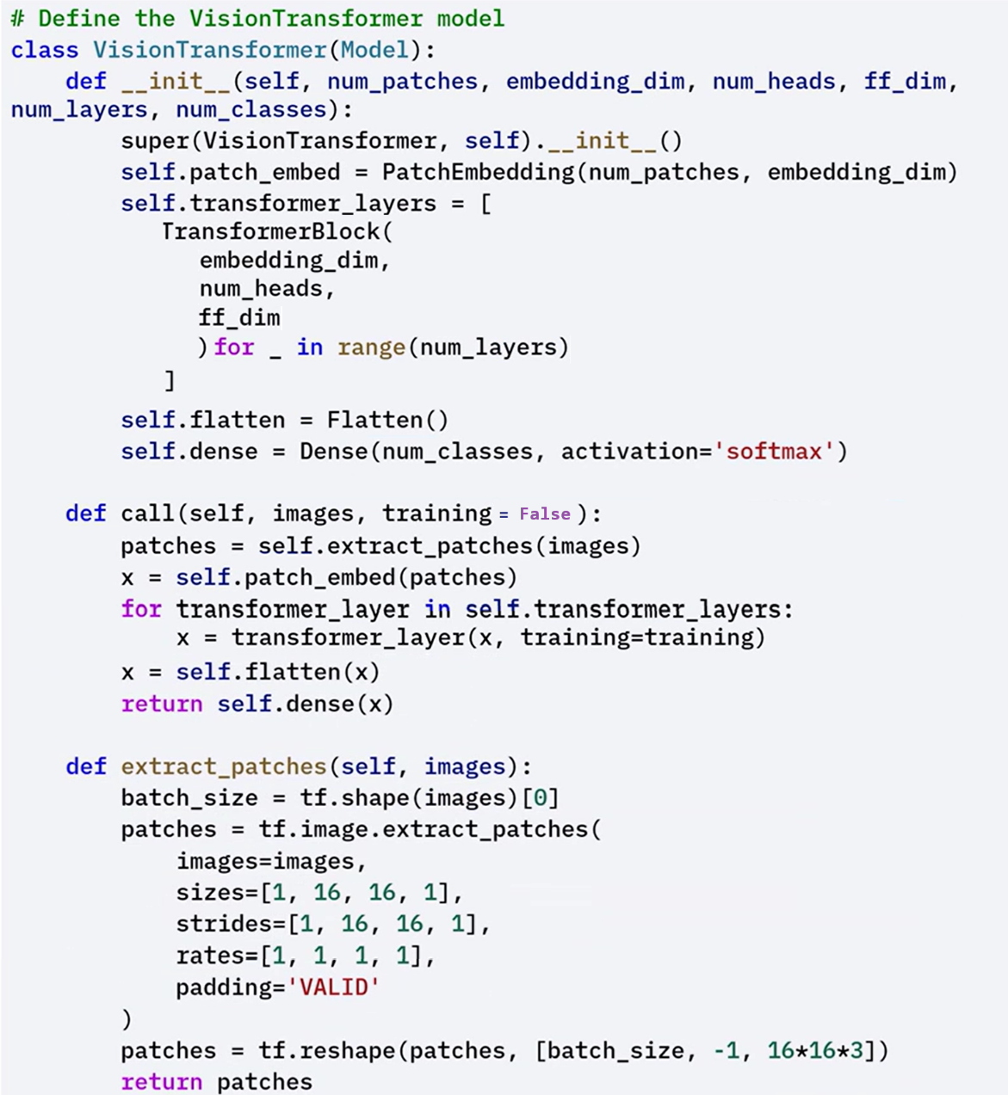

⚙️The example usage demonstrates how to create and use the vision transformer model for image classification.

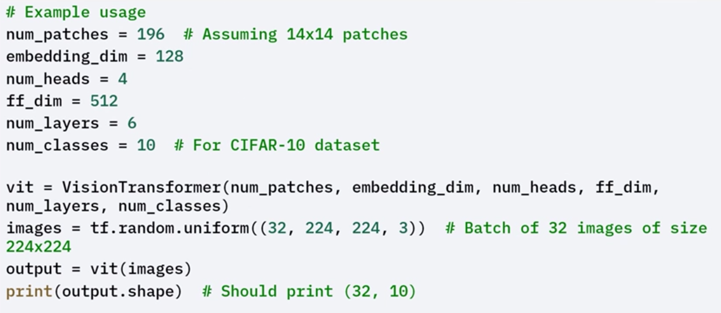

### 🔊 Transformers in Speech Recognition

Transformers can process speech by first converting audio signals into **spectrograms**, which are 2D representations of sound over time. These spectrograms are then treated as sequences, allowing transformers to model the temporal structure of speech.

**Key Steps:**

1. Convert audio signals into spectrograms.
2. Define a **SpeechTransformer** model that includes:

* **Convolutional layers** to capture local patterns
* **Transformer blocks** to model long-term dependencies

1. Apply self-attention and feed-forward networks in each transformer layer.
2. Use residual connections and layer normalization for stable training.

This approach has led to models like **Wav2Vec** and **SpeechTransformer**, which perform competitively in speech-to-text tasks.

**Components:**

**🔧** **TransformerBlock:**

Implements self-attention and feed-forward sub-layers. Includes residual connections and normalization.

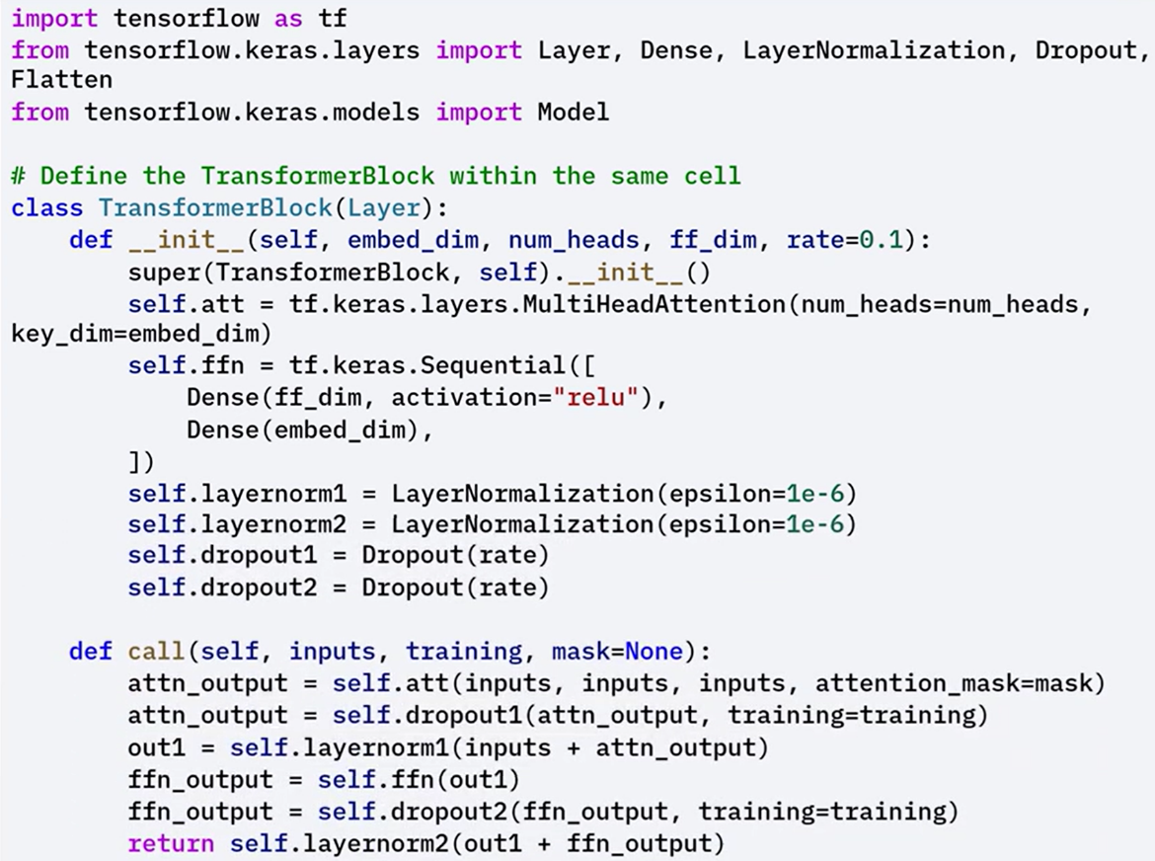

**🔧** **PatchEmbedding:**

Defines a layer that embeds self-projected patches.

Although patch embedding is typically for vision, it’s conceptually similar in audio processing, where segments of the spectrogram may be projected before attention layers.

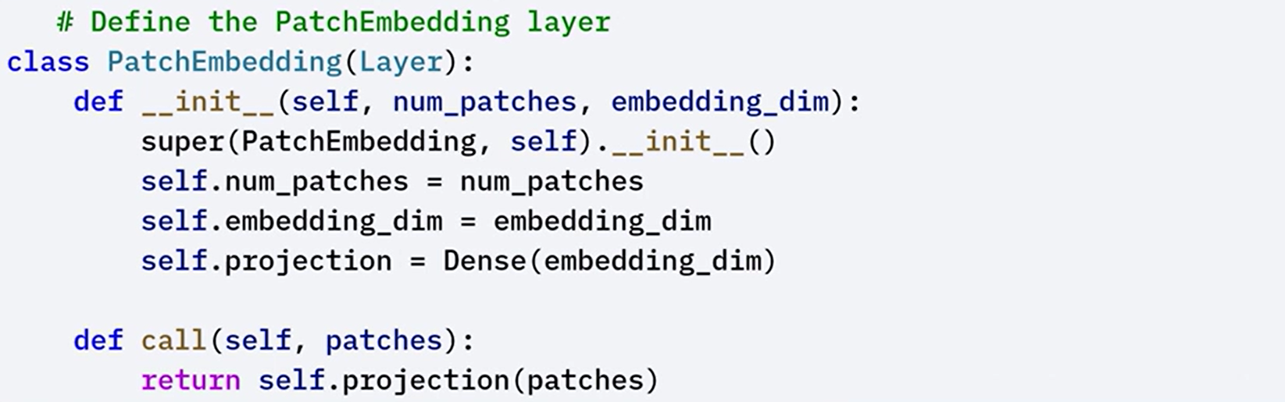

**🔧SpeechTransformer:**

Defines the overall architecture using convolutional and transformer layers to process sequential speech data.

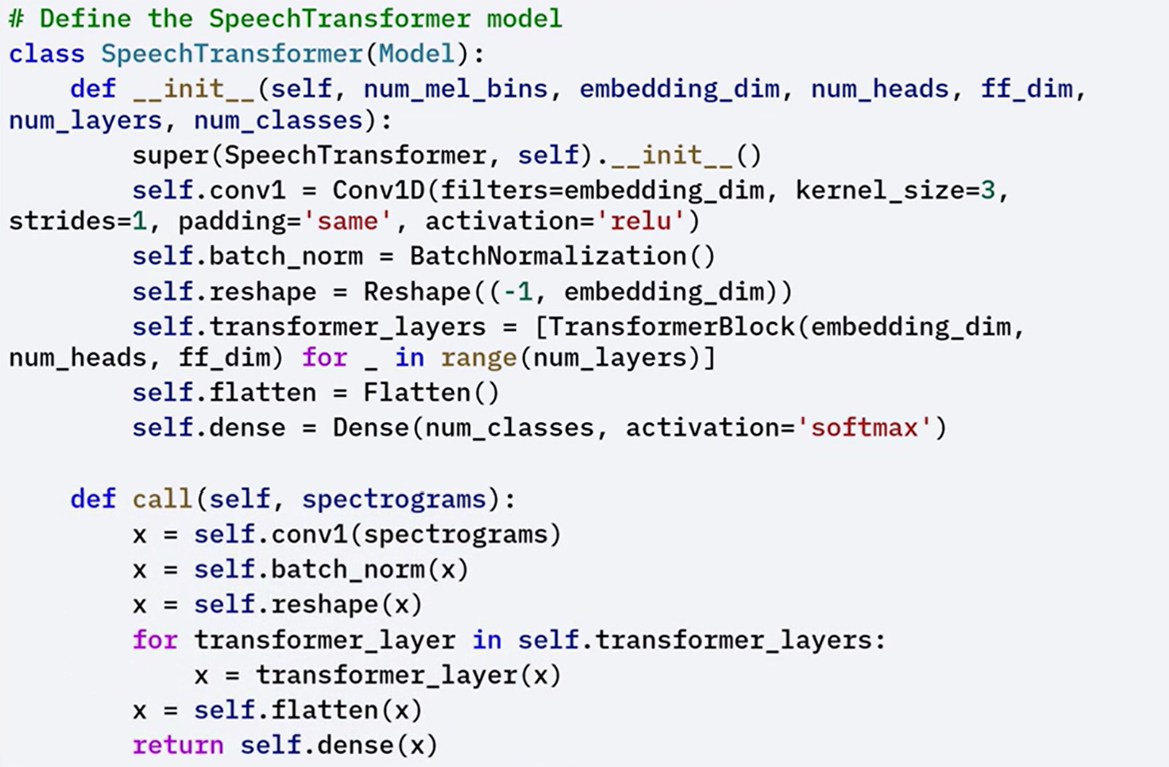

⚙️The example usage demonstrates how to create and use speech transformer model for speech recognition.

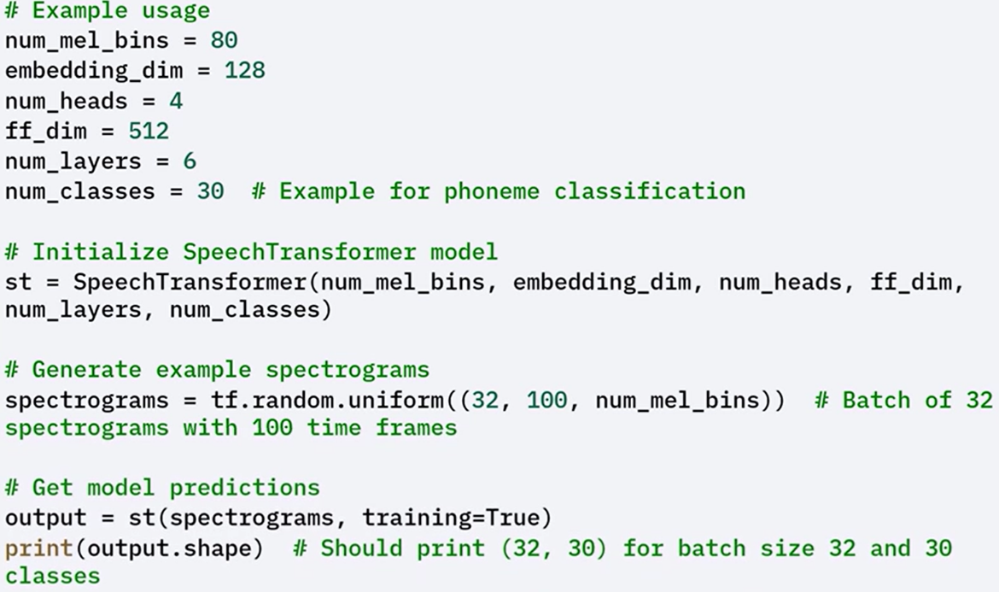

### 🎮 Transformers in Reinforcement Learning

Transformers are also used in **reinforcement learning** to model sequences of states, actions, and rewards. This allows them to capture complex dependencies in long trajectories and learn patterns from past experience.

The **Decision Transformer** is a transformer-based model designed to predict the next action based on historical context, rather than using value-based or policy-based objectives. It processes entire trajectories as input sequences and learns directly from return-conditioned sequences.

**Key Steps:**

1. Embed the sequence of past states, actions, and returns.
2. Use a transformer block to model the dependencies across time steps.
3. Output the predicted action based on context from the full trajectory.

**Components:**

**🔧** **TransformerBlock:**

Defines the building block of the model, including self-attention and feed-forward sub-layers.  
The call() method handles the computation of attention outputs and their transformation through the feed-forward layer, followed by residual and normalization layers.

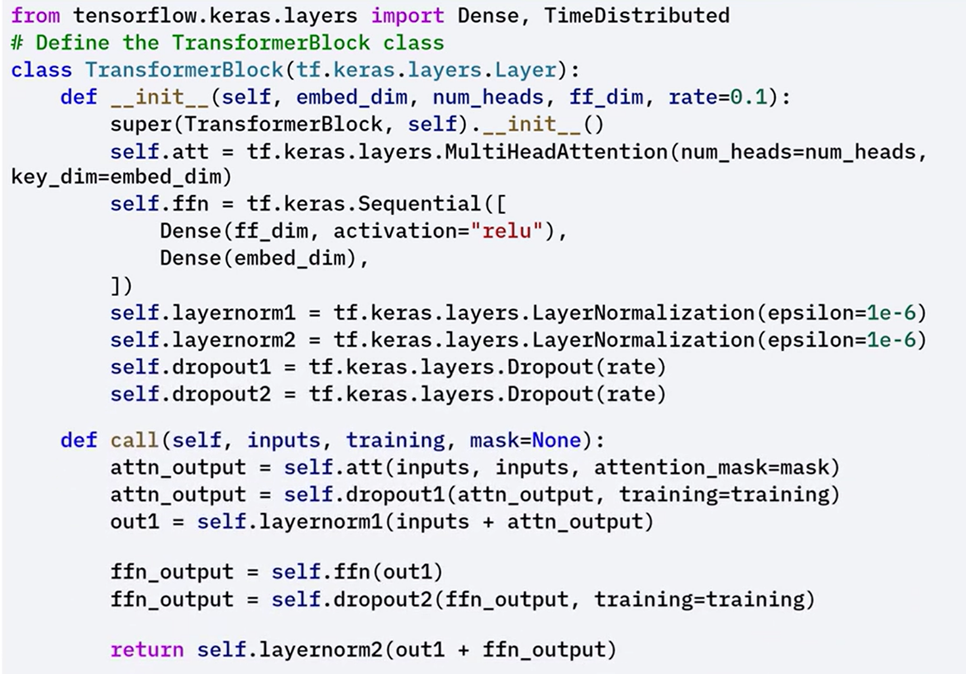

**🔧** **DecisionTransformer:**

Implements the full transformer model tailored for RL.

The call() method applies embeddings for sequences of returns, states, and actions, then feeds them through transformer layers to generate action predictions.

Applies embedding logic and transformer computations to process entire trajectories and produce predictions.

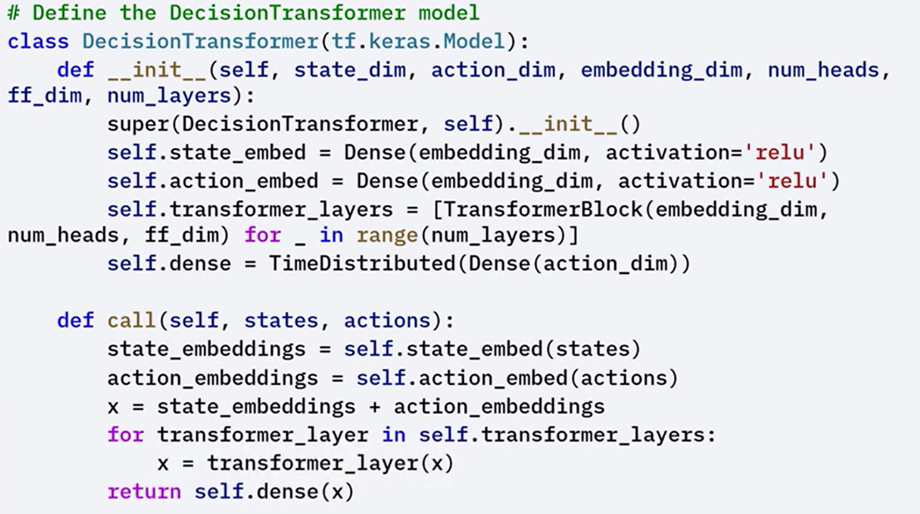



This architecture allows transformers to operate directly on RL trajectories, offering a unified modeling approach for decision making across sequential environments. By conditioning on past rewards and actions, decision transformers enable **policy learning without traditional reinforcement learning objectives**.

⚙️The example usage demonstrates how to instantiate the **DecisionTransformer** model and use it for predicting the next action in an environment using historical state-action-reward data..

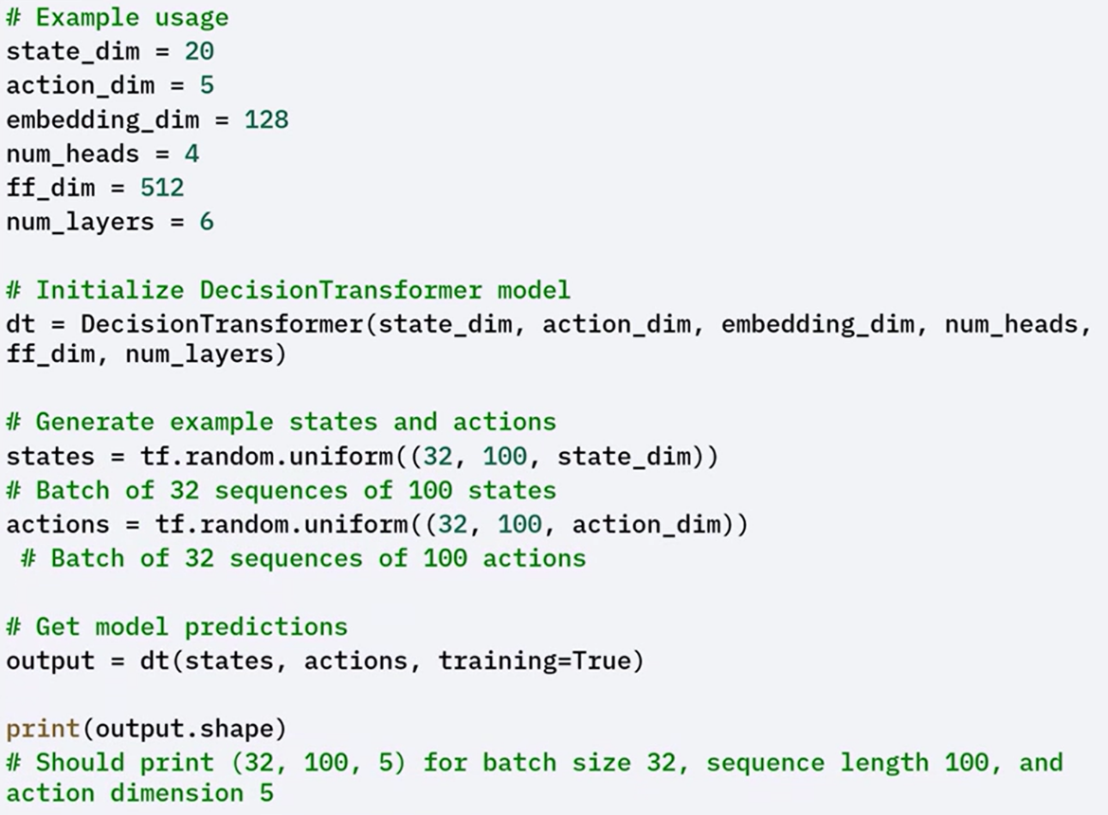

### ✅ Takeaways

✅ Transformers are not limited to text; they are highly adaptable and effective in image, audio, and control-based tasks.

✅ Vision Transformers use self-attention on image patches for classification.

✅ Speech Transformers process spectrograms to model audio data sequentially.

✅ Decision Transformers use transformer architecture to model trajectories for decision making in reinforcement learning.

✅ Each application uses the same core principles: self-attention, feed-forward networks, residual connections, and normalization — but adapts the input structure to the specific domain.

## 📈 Transformers for Time Series Prediction

Transformers can be applied to time series forecasting tasks by modeling sequences of numerical data collected at regular intervals.

These models offer an efficient and scalable alternative to traditional forecasting methods.

### 🔹 Time Series Forecasting Overview

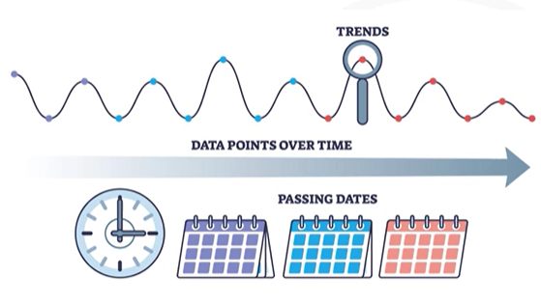

Time series data is a sequence of values recorded over time — for example, stock prices, weather measurements, or sensor readings.  
Forecasting involves predicting the next value(s) in the sequence based on historical data.

Traditional models include:

* **ARIMA** (AutoRegressive Integrated Moving Average)
* **RNNs** (Recurrent Neural Networks)
* **LSTMs** (Long Short-Term Memory networks)

While effective, these models have limitations in capturing long-term dependencies and parallelizing computation.

Transformers address these limitations using **self-attention**, which enables the model to consider the entire sequence at once and efficiently capture dependencies over long time ranges.

### 🔹 Key Advantages of Transformers for Time Series

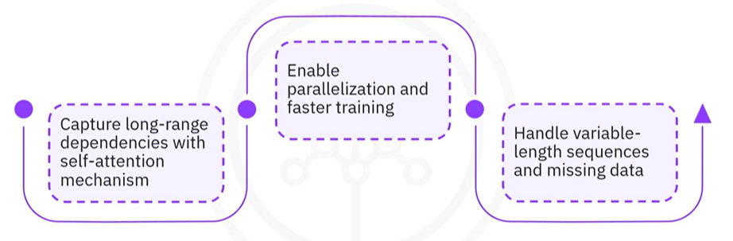

* **Self-attention mechanism** models long-range relationships more effectively than recurrent models.
* **Parallel computation** speeds up training by processing entire sequences simultaneously.
* **Flexible sequence handling** allows working with variable-length inputs and incomplete data.

These strengths make transformers especially useful in time series forecasting applications where dependencies across many time steps matter.

### 🔹 Building a Transformer for Time Series with Keras

To build a time series forecasting model using Keras, follow this step-by-step structure:

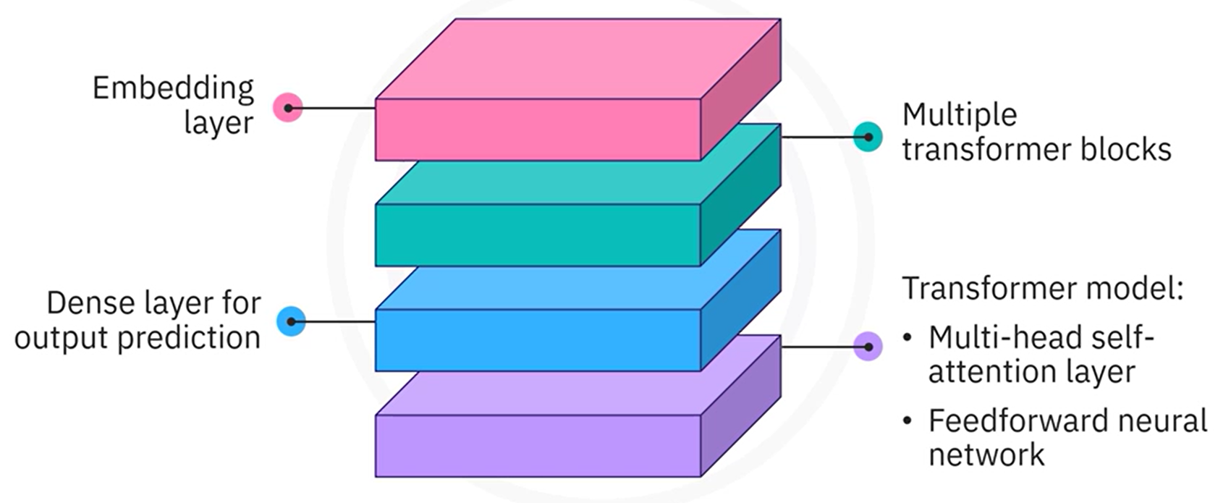

**🔁 Key Steps:**

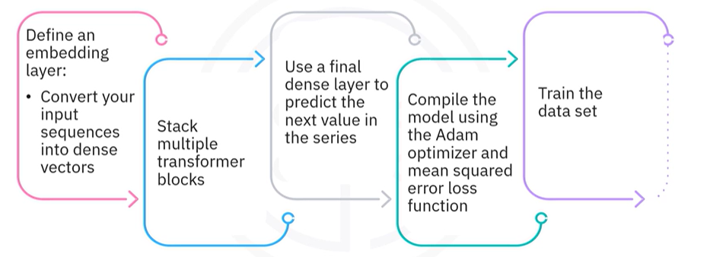

1. Normalize the dataset and convert it into input sequences and next-step labels.
2. Define an embedding layer to transform input sequences into dense vectors.
3. Stack multiple transformer blocks, each containing self-attention and feed-forward layers.
4. Add a final dense layer to output the predicted next value in the sequence.
5. Compile the model using the Adam optimizer and mean squared error loss.
6. Train the model using the prepared time series data.

#### 🧩 Preparing Time Series Data

1. Normalize the data using a **MinMaxScaler** to map values between 0 and 1.
2. Split the normalized series into input sequences and corresponding labels.
   * Each input contains a fixed number of past time steps.
   * The label is the next value in the sequence.
3. Print shapes and check for missing values to validate the preparation}

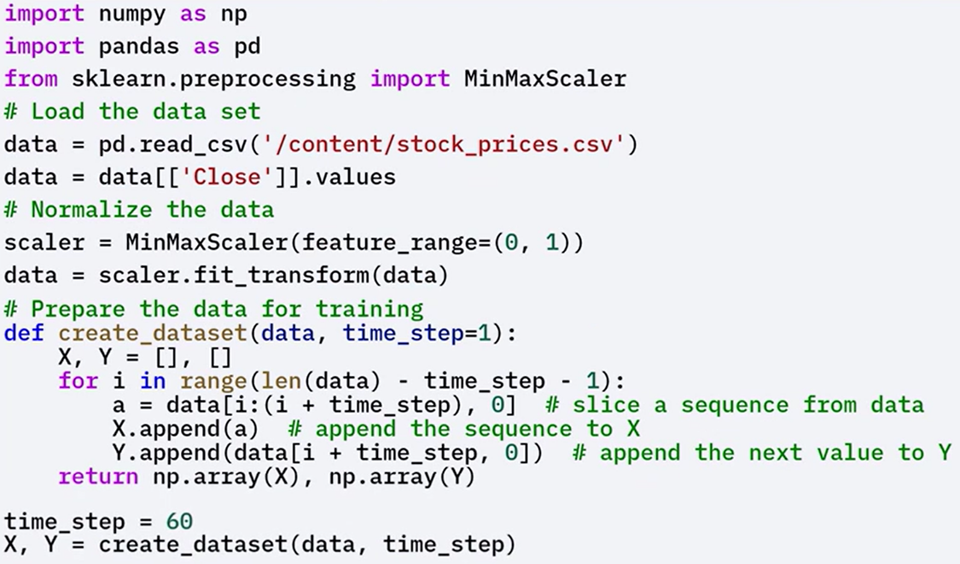

#### 🧩 Model Components

**🔧** **TransformerBlock:**

Defines a transformer layer that includes, Multi-head self-attention layer, Feed-forward network, Residual connections and layer normalization.

The call() method applies these operations in the correct order.

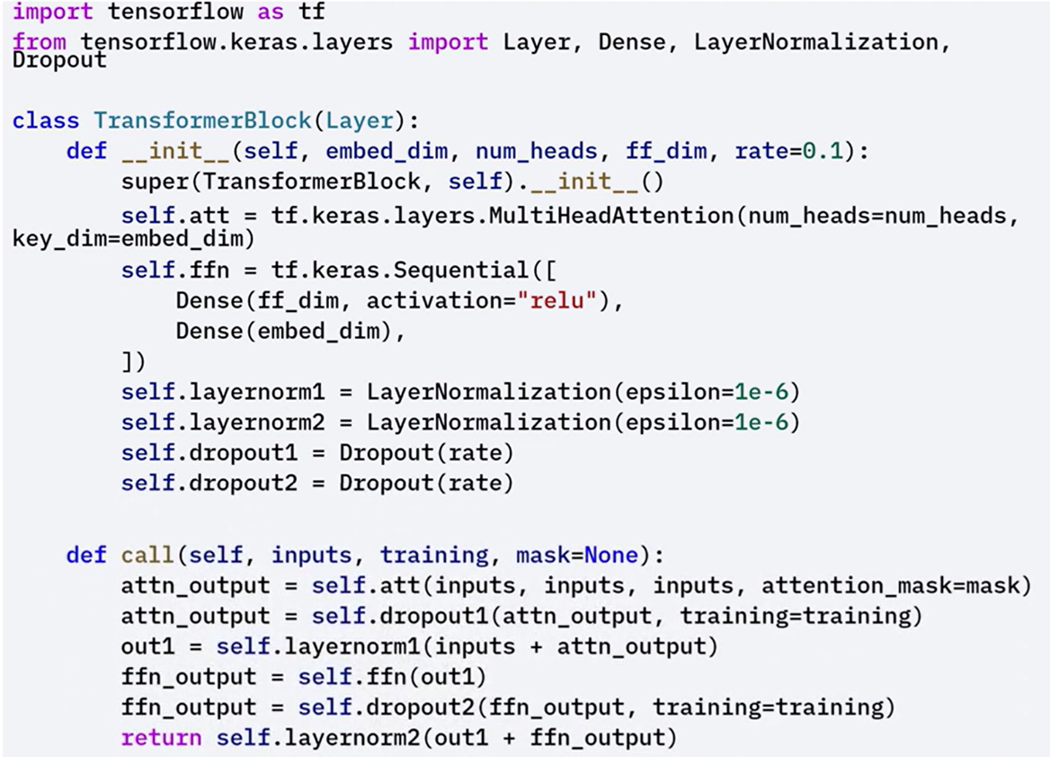

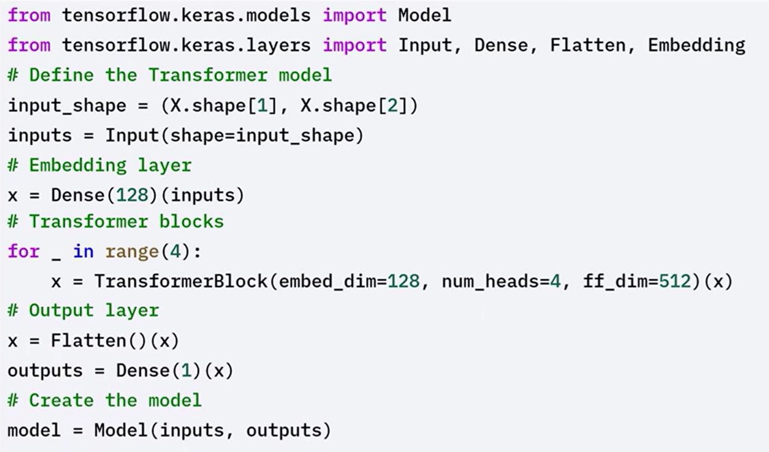**🔧** **Embedding Layer:**

Converts input sequences (time steps) into dense vectors that can be processed by the transformer.

**🔧** **Dense Layer:**

Produces the final prediction — the next value in the time series.

#### 🧩 Training and Evaluation

After preparing the data and defining the model, train and evaluate the forecasting model:

1. Train the model using the input sequences and next-step labels.
2. Use the model to predict future values.
3. Inverse transform the predictions back to the original scale.
4. Plot both the actual values and predicted values to visualize performance.

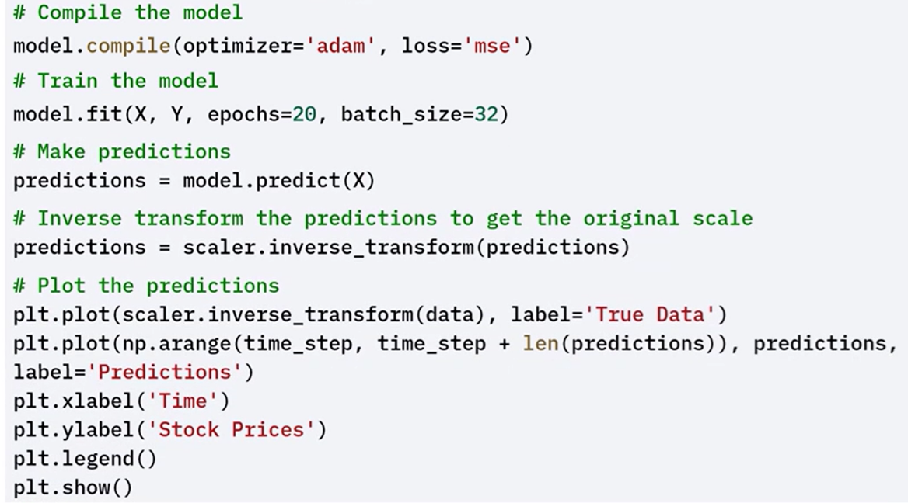

### ✅ Takeaways

✅ Transformers can be applied to time series forecasting by modeling sequences of past values.

✅ Self-attention enables transformers to capture long-range dependencies more effectively than RNNs or LSTMs.

✅ The model architecture includes:

* An **embedding layer** for input transformation
* One or more **transformer blocks** to process the sequence
* A **dense output layer** for prediction

✅ Keras provides a flexible framework for building, training, and evaluating such models end-to-end.

## 📈 TensorFlow for Sequential Data

TensorFlow provides a rich set of tools for building and training models on **sequential data**.

This includes time series, text, and audio — all of which require preserving the order of data points and capturing dependencies across time or position.

### 🔹 Understanding Sequential Data

Sequential data is defined by the **order and structure of its elements**. Each point depends on those that come before it.

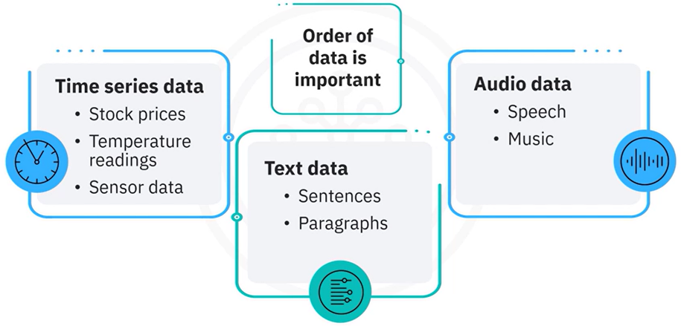

Modeling this type of data requires architectures that can **understand and learn from sequences**,recognizingboth **short-term** and **long-term dependencies**.

### 🔹 TensorFlow Tools for Sequence Modeling

TensorFlow includes several layers and components specifically designed for sequential data:

* 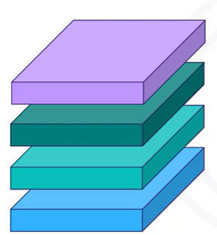**RNN (Recurrent Neural Network)** layers
* **LSTM (Long Short-Term Memory)** layers
* **GRU (Gated Recurrent Unit)** layers
* **Conv1D (1D Convolution)** layers for sequential pattern detection
* **TextVectorization** for transforming text into numeric tensors

These components allow TensorFlow to be used in a wide range of sequence-based tasks including:

* **Time series forecasting**
* **Natural language processing**
* **Speech recognition**

### 🔹 Building Sequence Models with TensorFlow

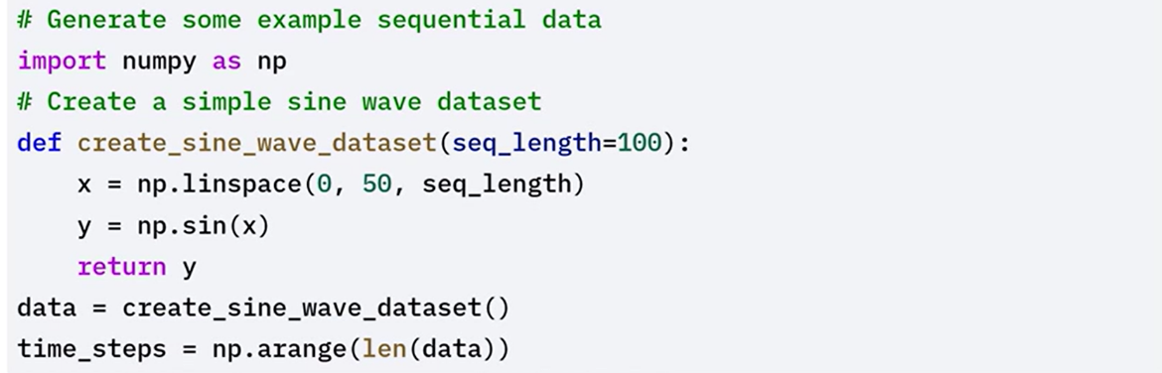

#### 🛠 RNN for Time Series Prediction

1. Create input sequences and matching labels.
2. Build a model using:

* A **SimpleRNN** layer
* A **Dense** layer for output prediction

1. Compile and train the model.
2. Make predictions and plot the results to evaluate performance.

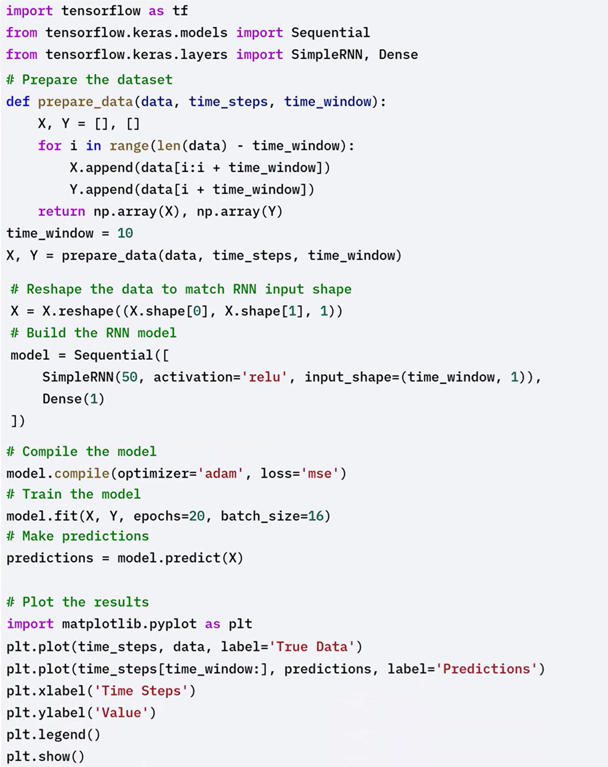



#### 🛠 LSTM for Long-Term Dependency Modeling

LSTMs are a type of RNN that are capable of learning long-term dependencies, making them suitable for sequential data with long-term patterns.

Using the same sine wave dataset generated before, the steps for LSTM modeling are as follows:

1. Replace the **SimpleRNN** layer with an **LSTM** layer.
2. Keep the rest of the model structure the same.
3. Compile and train the model.
4. Generate predictions and compare them with the original data to see improvements in learning longer patterns.

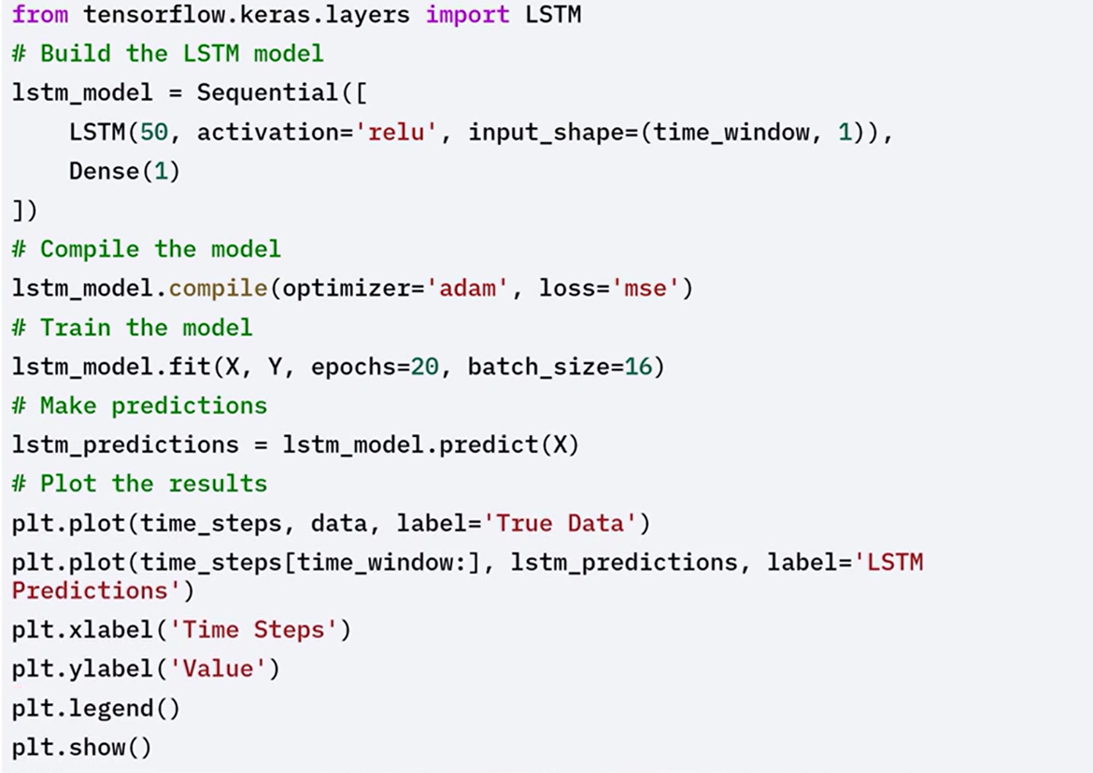

#### 🛠 Handling text data with TensorFlow

Text data requires specific pre-processing steps such as tokenization and padding.

TensorFlow's text vectorization layer helps in converting text data into numerical format suitable for model training.

1. Create a **TextVectorization** layer.

* Tokenizes text
* Pads sequences to ensure consistent input shape

1. Adapt the vectorizer to the dataset.
2. Transform the text into numerical sequences suitable for model input.

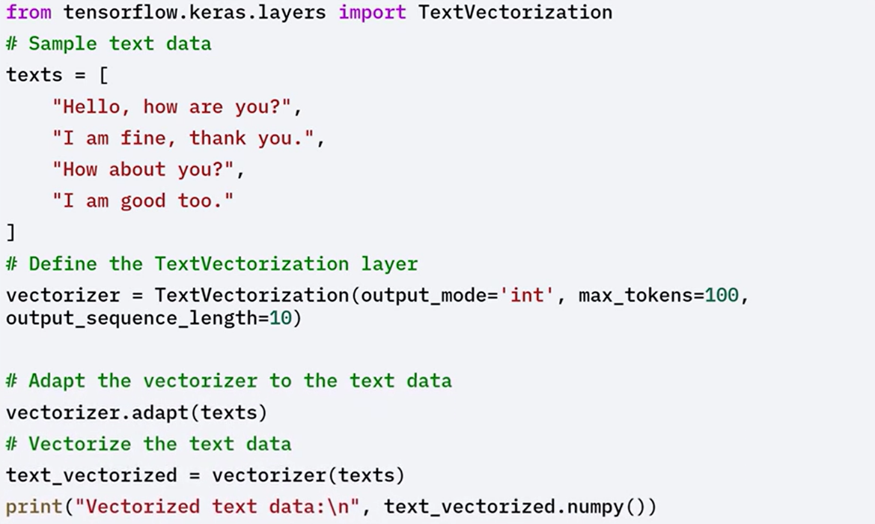

### ✅ Takeaways

✅ Sequential data depends on the order of data points, making it important to use models that can retain and learn from temporal structure.

✅ TensorFlow supports a variety of layers for sequence modeling including RNNs, LSTMs, GRUs, and Conv1D.

✅ Time series data can be modeled using simple RNN or LSTM layers to predict future values based on past inputs.

✅ Text data requires preprocessing through tokenization and padding before being passed to a model. TensorFlow's TextVectorization layer simplifies this step.

✅ TensorFlow provides all necessary components to build, train, and evaluate models on structured sequential data.